Assignment 8
Technical questions about this assignment can be asked only in the computer lab (week 11).

To be started in: week 11 before attending the computer lab
Due: At the start of your computer lab session in week 12, you should demonstrate your programs to your tutor and answer his/her questions about your programs.

- As you learned, divide and concur strategy, which is the concept behind recursion is a very powerful strategy to present solutions for many hard-to-solve problems including some games provided in the Internet. In lecture 10, you learned about solving the “tiles and board” problem with recursion. Write a PHP program that reads the value of m and solves the corresponding “tiles and board” problem.

The location of the initial black cell is given to the program through its corresponding row and column, as input by the user.

Note that the size of the board is 2^{m} and in your PHP program the user can select m as any integer less than 6. The output of the program should be a HTML table in which the number of the corresponding tile fills the cells it sits in. For the initial black cell no number sits in the corresponding place.

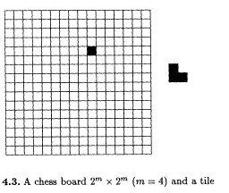
- Change your code so that instead of numbers, tiles with different colours fill the table.
As well as doing the above tasks, the postgraduate students need to search the Internet and create a brief report of 300 words comparing iterative and recursive methods.
The assignment has 3 marks distributed as follows:
- Writing the recursive program and filling the table (with numbers and colours) is worth 2 marks.
- Writing the code your tutor requests in the lab is worth 2 marks.

